SPRINT-4

|  |  |
| --- | --- |
| Date | 07 November 2022 |
| TEAM ID | PNT2022TMID40963 |
| Project Name Project Members | IoT Based smart crop Protection system for agriculture  Shobana sri .M  Vedha prIya K.M.  Jaya sri .G |
| Maximum mark | 20 marks |

STEP 1: MIT APP inventor to design the APP.

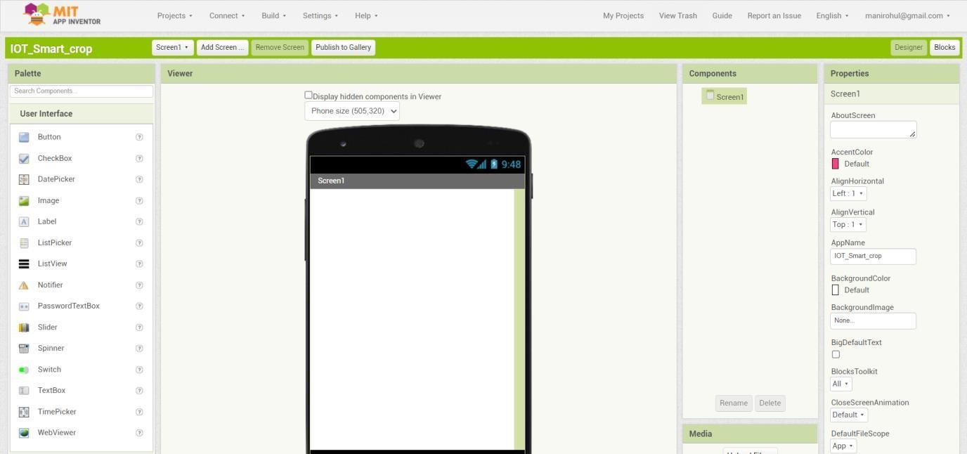

STEP 2: Customize the App interface to Display the Values.

